Nanchang University

School of Software

Assignment Task Book

Title ： Online Shopping System Design and Implemention

Major Software Engineering
Class 2023级软件工程来华留学生班
Student ID： 8002L23002
Student Name： UMAR ABDULKARIM 游马
Starting and ending dates： 2025.8.30～2025.9.15
Teacher： Jun Hu Professional Title: Professor
Department Director：
Completion Time： 2025.9,15

Online Shopping System

Assignment Task:
Firstly, using Navicat and MySQL, design a database named shoppingline. Secondly, using PhP and MySQL, implement a Web-based application for an online video-store. Finally, write a project report about details for designing database and implementation of a Web-based application system, such as ER diagram, relational schema, physical model, normalization, tables description, query, data dictionary, interface, and so on.

The online video-store maintains an inventory of DVDs. Customers become member of this online store. They are able to search for DVDs of their interest and add DVDs to their shopping cart. At any time, they are able to edit the shopping cart and also are able to check out. The initial login screen shown in the Figure 1 allows an existing customer to sign in or a new customer to register. The new customer registration screen is shown in Figure 2. Upon successful sign-in, the 3-frame page shown in Figure 3 is displayed. As one can see, there are six different options for the customer:
1. Search by Keyword: This option allows the customer to perform a keyword search of the DVD titles (substring; case insensitive comparison). Successful matches are shown on the right frame (Figure 4). The customer may then choose certain quantities of the DVDs and add them to the shopping cart. Upon successful addition to the shopping cart, a message should be shown on the right frame.
2. View/Edit Cart: Upon clicking this option, the system should display the shopping cart on the right side frame (Figure 5). Here, the customer may edit the shopping cart by changing quantities including replacing a value with a zero. Upon submission, the cart should be updated and a message should be displayed.
3. Update Profile: This option brings up the customers profile (Figure 6) on the right frame. The user may modify any field and submit. Upon successful update, a message should be displayed.
4. Check Order Status: This option allows the customer to see all their orders (Figure 7). Upon clicking the order number link the details for that order should be displayed in a tabular format.
5. Check Out: Upon clicking this link, the system should empty the cart and move the items into the orders and odetails tables. An invoice (Figure 8) should be printed on the right frame.
6. Logout: Upon logout, the system should display 3 Options (Figure 9) to the user. The user may check out, save cart and logout or empty cart and logout. Upon checkout a similar action should take place as earlier. Upon the other two options, appropriate action should take place and a message should be displayed. If the cart was empty to begin with these 3 options should not be shown and the customer should be logged out.

Online Video Store Web Application Project Report

Title Page
Project Title: Online Video Store Web Application
Database Name: shoppingline (MySQL)
Frontend/Backend: PHP, HTML, CSS
Database Tool: Navicat with MySQL
Prepared by: UMAR ABDULKARIM
Submitted to: 胡军
Course: Database System Design and Development Training
Date: 10th/September/2025

Table of Contents
- Introduction
- Objectives
- Database Design
  - ER Diagram
  - Relational Schema
  - Normalization Process
  - Physical Model
  - Tables Description
  - Data Dictionary
- System Implementation
  - Functional Modules
  - User Interface Screenshots
  - Navigation Flow
- Queries and Operations
- Results & Discussion
- Limitations & Future Improvements
- Conclusion
- References

1. Introduction
The Online Video Store Web Application was developed to simulate a real-world e-commerce platform for DVDs. The system allows registered customers to:
- Create an account and log in securely.
- Search for DVDs using keywords.
- Add DVDs to a shopping cart and manage their cart.
- Proceed to checkout and confirm their order.
- View the order history and shipping status.
- Logout securely after completing activities.
The system was implemented using PHP for the server-side logic, HTML and CSS for the front-end design, and MySQL (via Navicat) for database design and management.

2. Objectives
- To design a normalized relational database for a shopping system.
- To implement a web-based application that interacts with the database.
- To allow customers to perform common shopping activities such as search, cart management, and checkout.
- To demonstrate secure login and logout functionality.
- To generate a project report with diagrams, database schema, and system screenshots.

3. Database Design

3.1 ER Diagram
The Entity-Relationship diagram represents the conceptual model of the database.
Entities:
- Customers
- DVD
- Cart
- Orders
- OrderDetails (odetails)
Relationships:
- One customer can place many orders.
- Each order contains multiple DVDs (through OrderDetails).
- A customer can have multiple DVDs in their cart.
ER Diagram
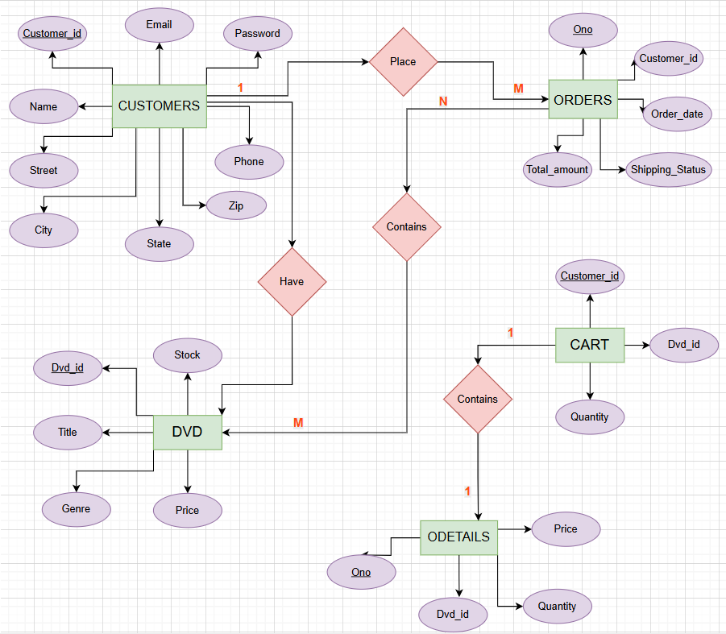

3.2 Relational Schema
- Customers(customer_id PK, name, street, city, state, zip, phone, email UNIQUE, password)
- DVD(dvd_id PK, title, genre, price, stock)
- Cart(customer_id PK, dvd_id PK, quantity)
- Orders(ono PK, customer_id FK, order_date, shipping_status, total_amount)
- Odetails(ono PK, dvd_id PK, quantity, price)
Diagram: Relational Schema
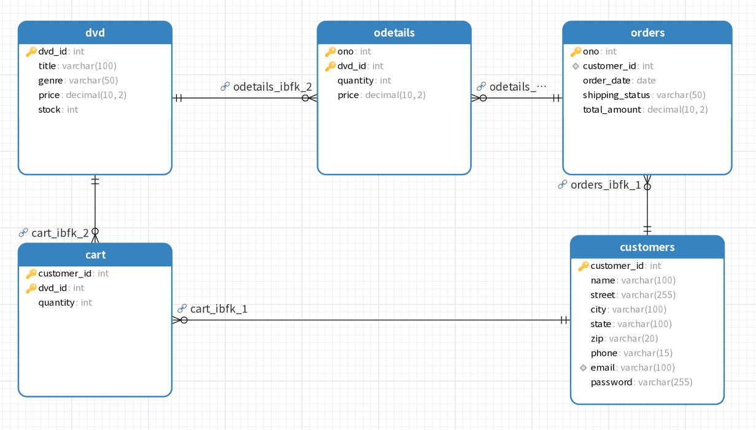

3.3 Normalization Process
- First Normal Form (1NF): All tables contain atomic values, no repeating groups.
- Second Normal Form (2NF): Composite keys (e.g., Cart and Odetails) ensure all non-key fields depend on the full key.
- Third Normal Form (3NF): No transitive dependencies. For example, customer email is independent of customer address.

3.4 Physical Model
Chosen data types:
- INT: IDs, quantity, stock.
- VARCHAR: Names, addresses, emails.
- DECIMAL(10,2): Prices and total amounts.
- DATE: Order dates.

3.5 Tables Description
- Customers: Stores personal details and login information.
- DVD: Catalog of DVDs available in the store.
- Cart: Temporary table for items selected by customers.
- Orders: Tracks purchases with dates and shipping status.
- Odetails: Line items of each order with DVD ID, quantity, and price.
Table’s Data
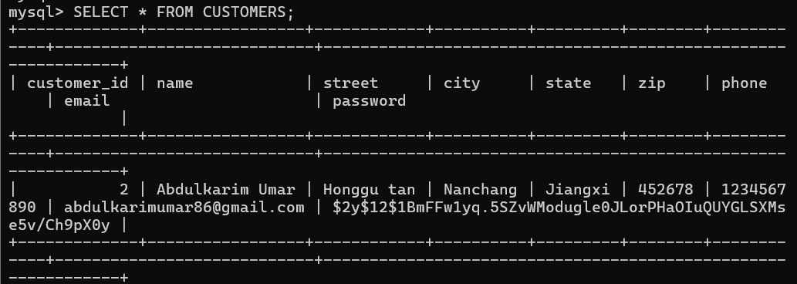
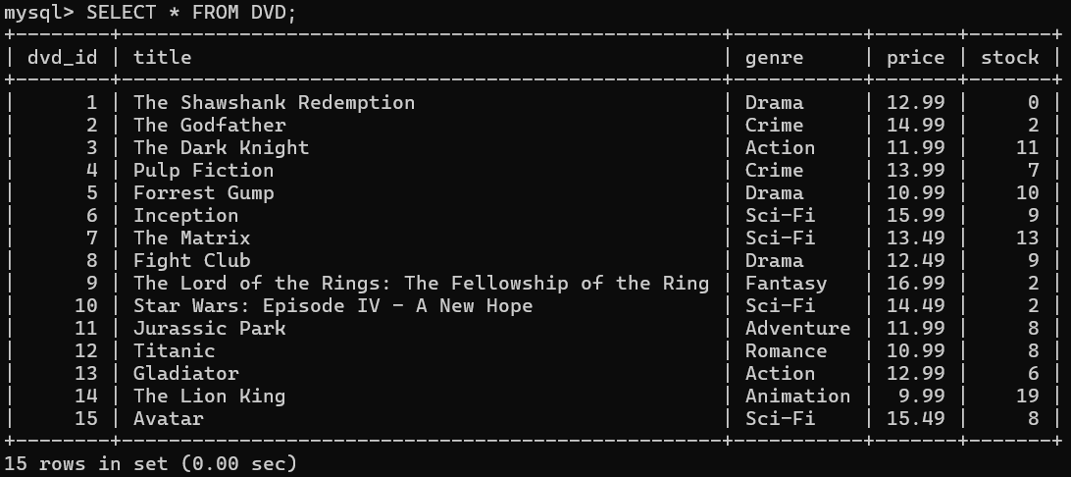

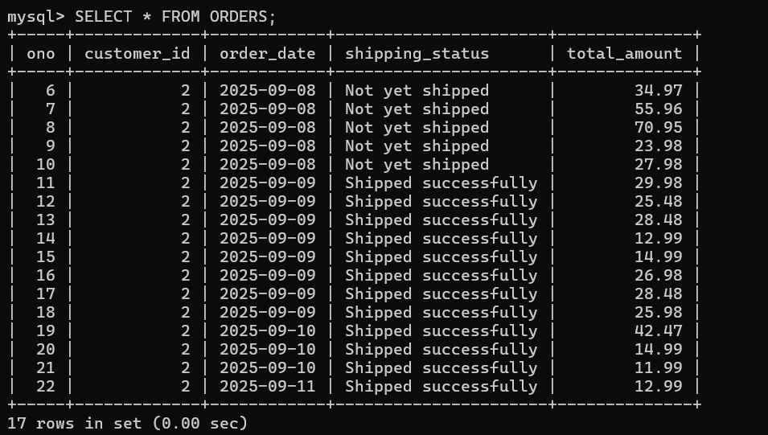
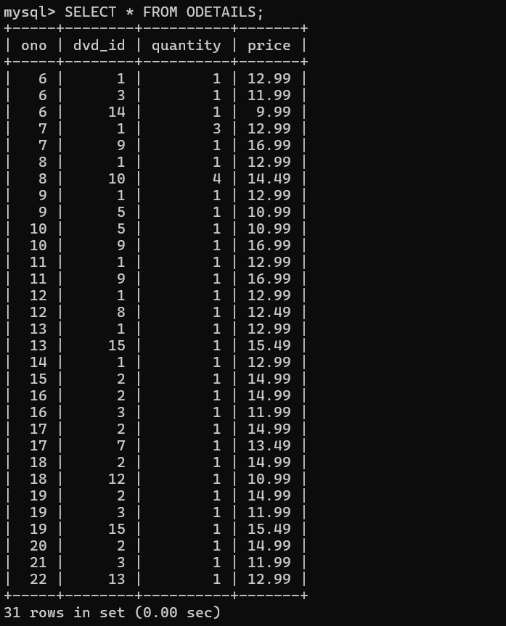

3.6 Data Dictionary

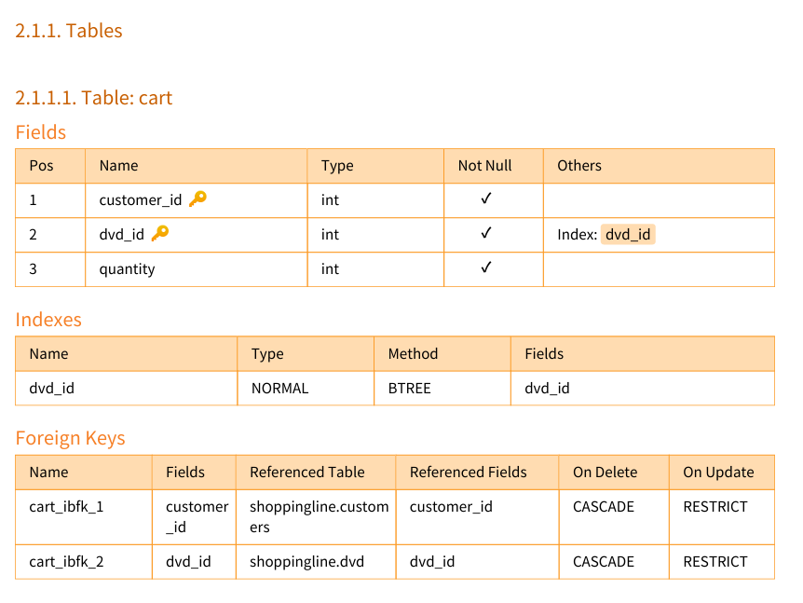

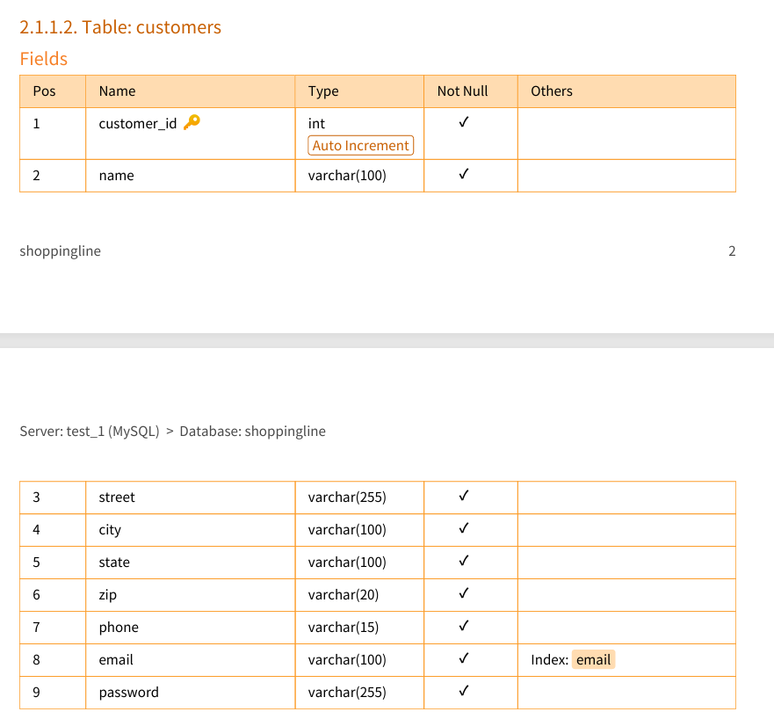

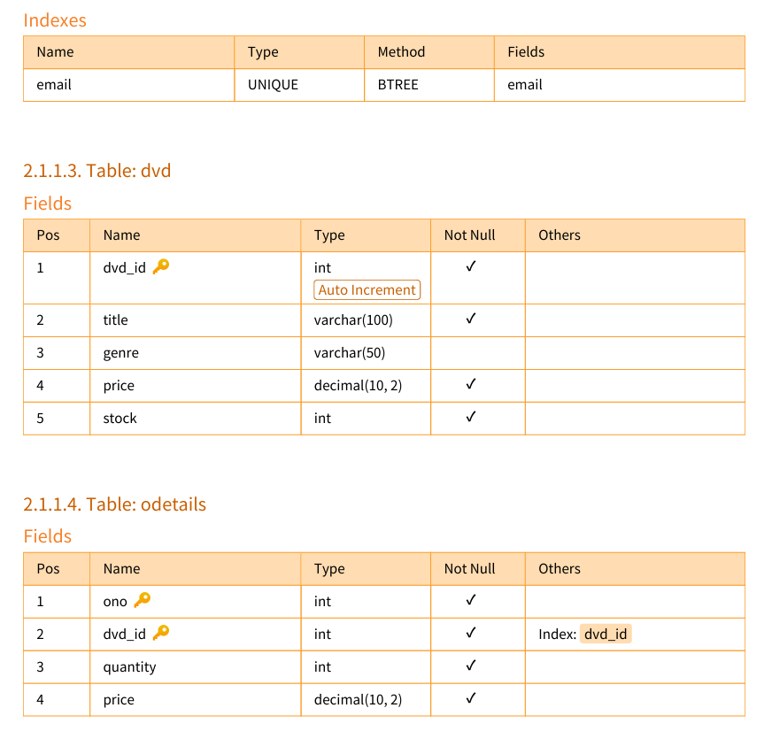

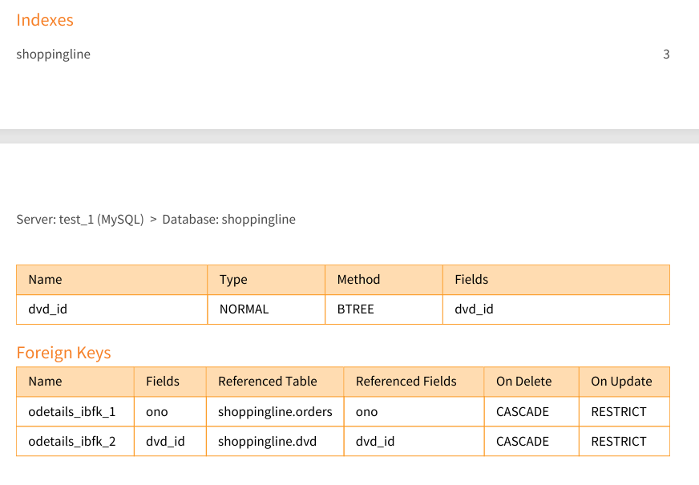

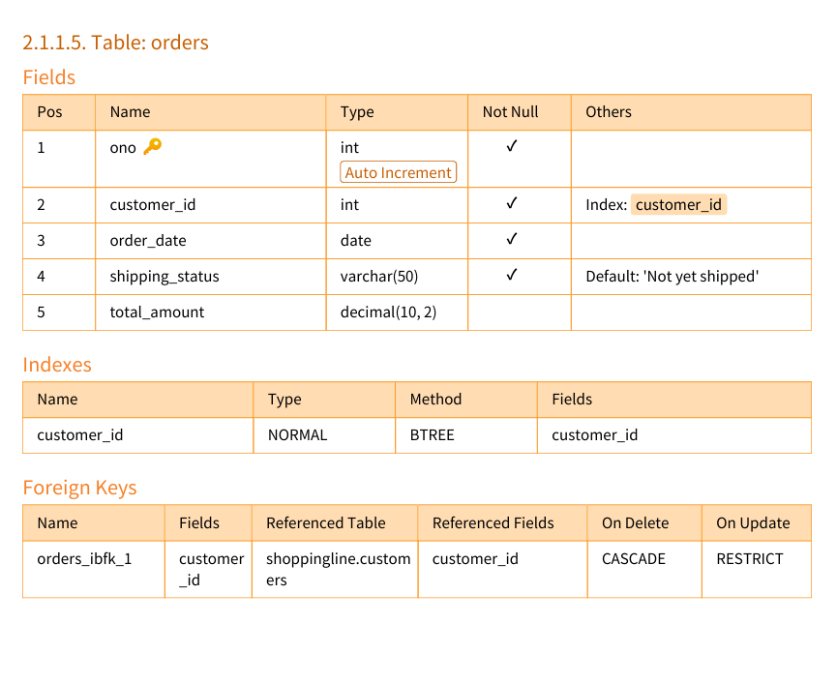

4. System Implementation

4.1 Functional Modules
- Login/Registration Module
- Customer Menu Module
- Search and Browse Module
- Cart Management Module
- Checkout Module
- Order Status Module
- Logout Module
Customer Menu Interface
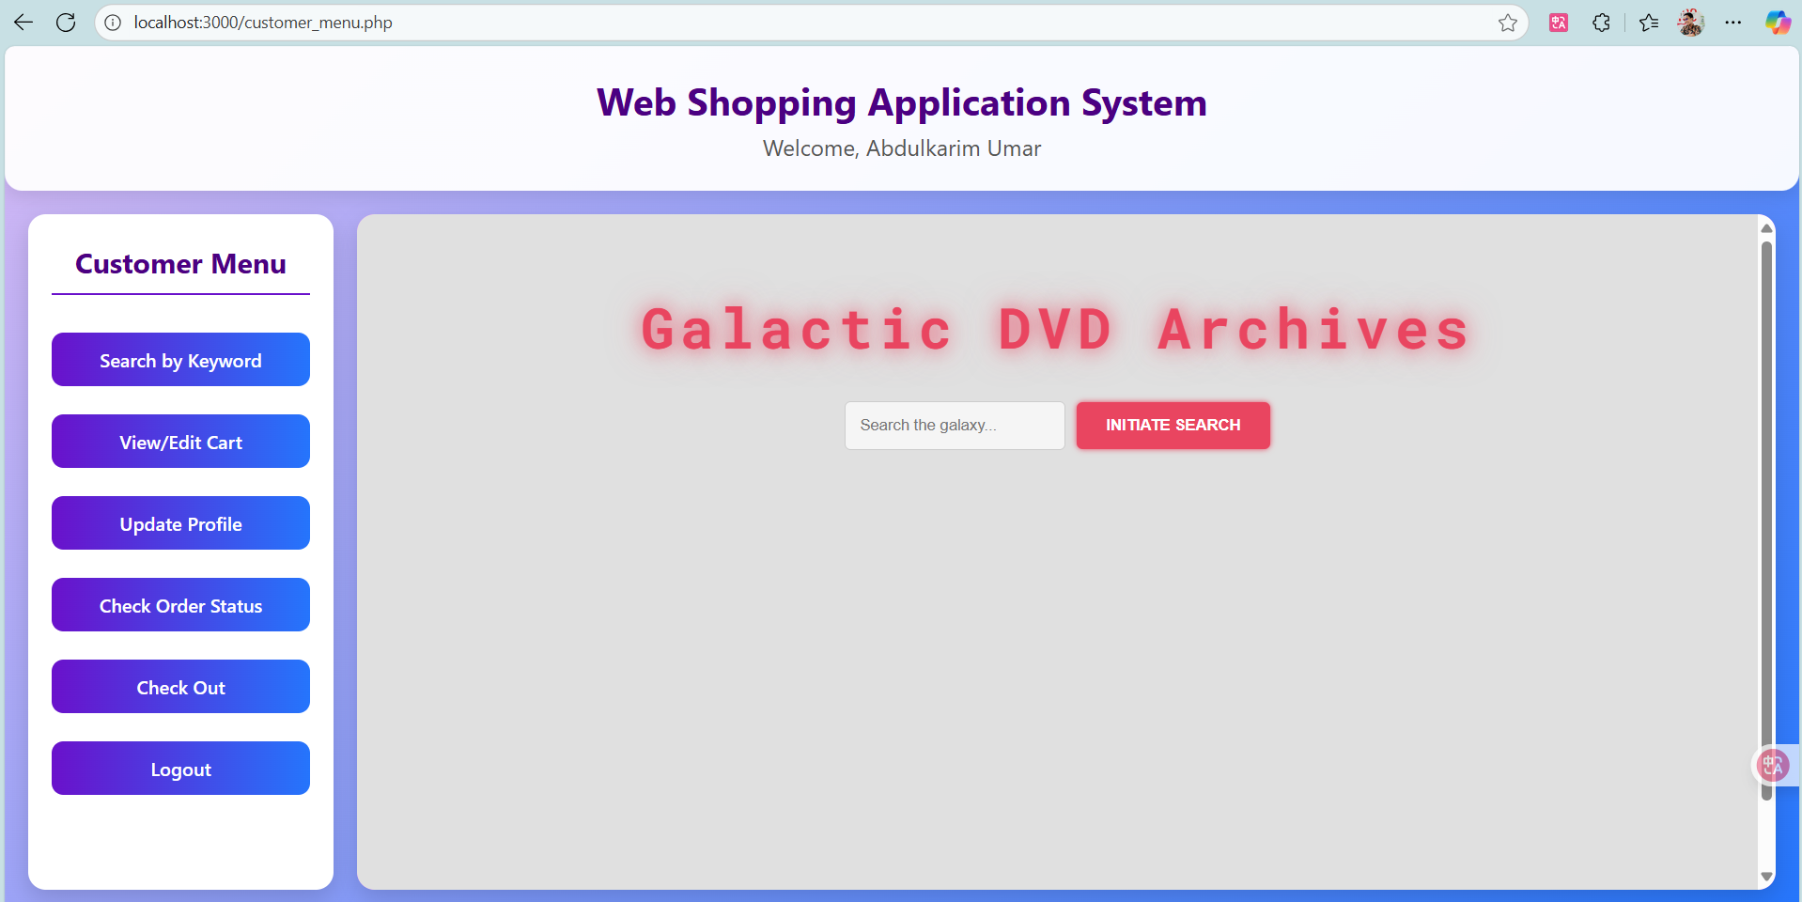

4.2 User Interface Screenshots
- Login/Registration Page
  - Allows customers to sign up or log in.
Login Page
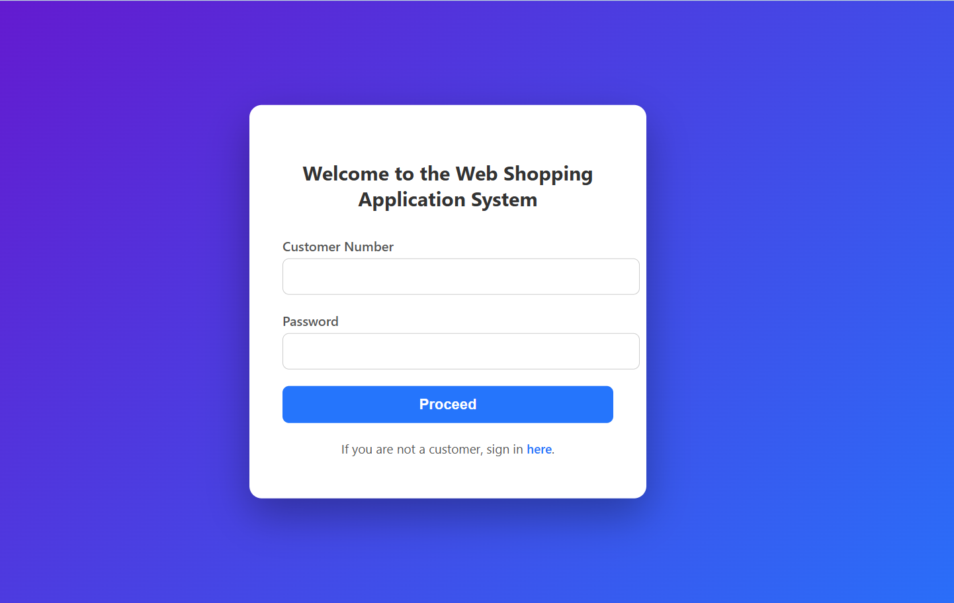

- Customer Menu
  - Navigation menu for accessing features.
Customer Menu

- Search Products
  - Keyword-based DVD search.
Search Page
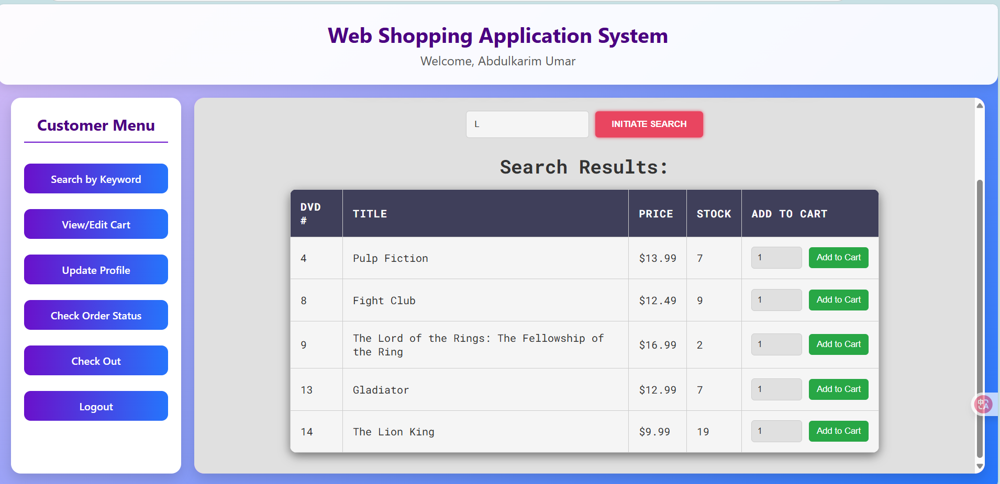

- Shopping Cart
  - Displays selected DVDs.
Cart Page
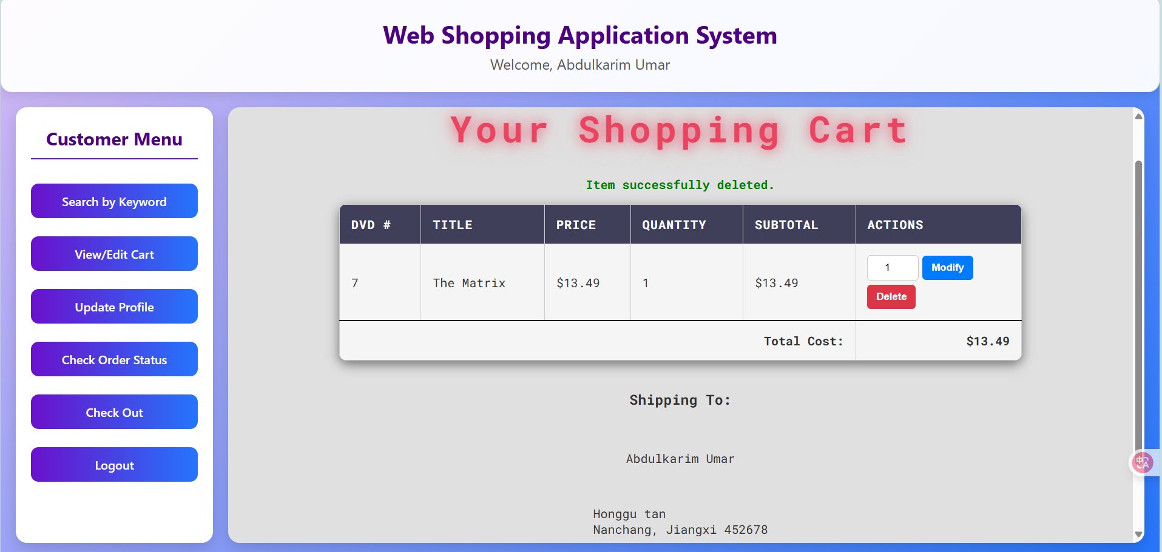

- Checkout Page
  - Displays shipping address and order summary.
Checkout Page
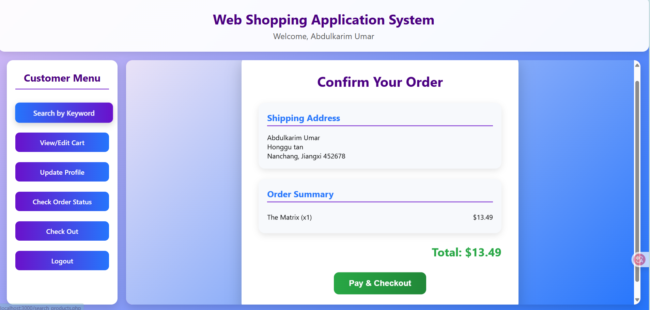

- Receipt Page
  - Displays receipt after checkout.
Receipt Page
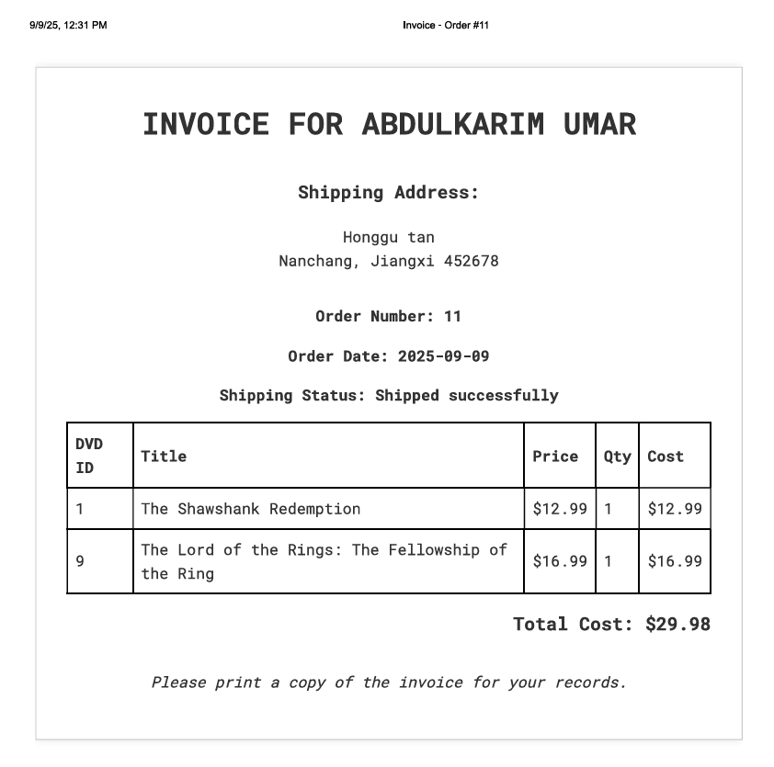

- Order Status Page
  - Displays shipping updates.
Order Status Page
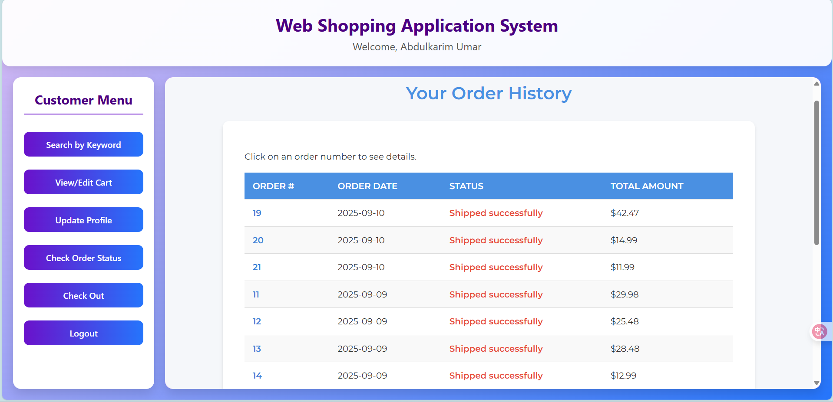

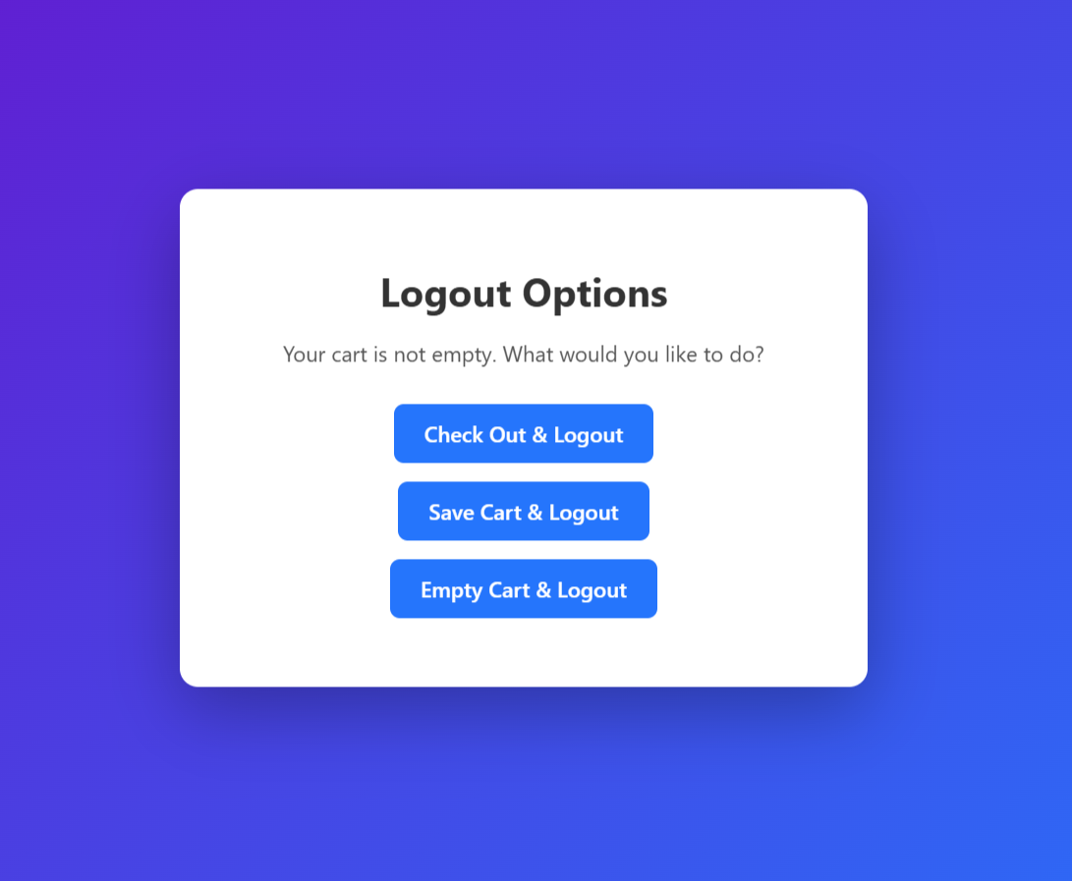

4.3 Navigation Flow
Flow of System Use:
Login → Customer Menu → Search DVDs → Add to Cart → Checkout → Receipt → Logout
Flowchart
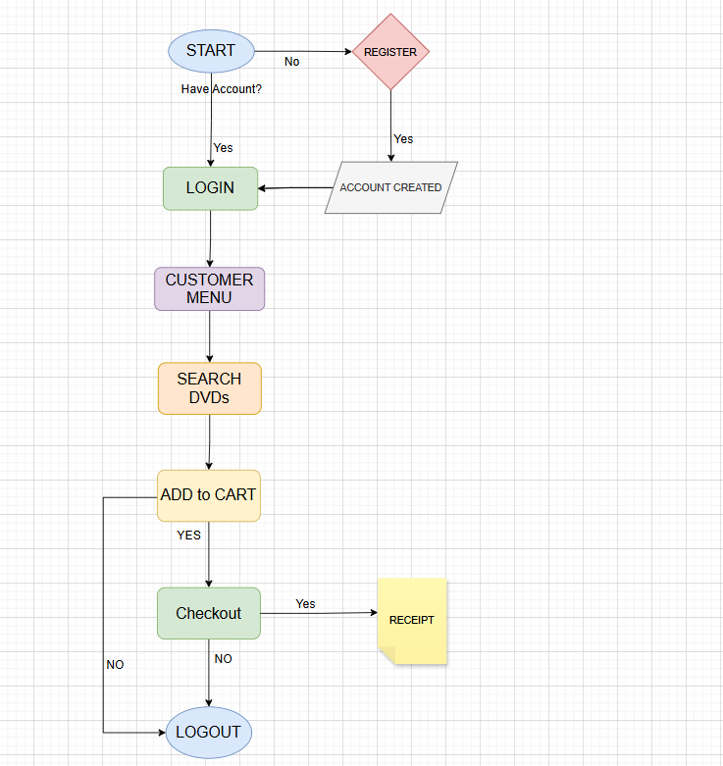

5. Queries and Operations
Examples:
- Search DVD by Title
SELECT * FROM dvd WHERE title LIKE '%Godfather%';
- Insert Order
INSERT INTO orders (customer_id, order_date, shipping_status, total_amount)
VALUES (2, CURDATE(), 'Not yet shipped', 29.99);
- View Cart
SELECT d.title, d.price, c.quantity
FROM cart c
JOIN dvd d ON c.dvd_id = d.dvd_id
WHERE c.customer_id = 2;
- Update Order Shipping Status
UPDATE orders SET shipping_status = 'Shipped successfully'
WHERE ono = 11;

5.1 Table Creation Queries

1. CART TABLE

| cart | CREATE TABLE `cart` (

`customer_id` int NOT NULL,

`dvd_id` int NOT NULL,

`quantity` int NOT NULL,

PRIMARY KEY (`customer_id`,`dvd_id`),

KEY `dvd_id` (`dvd_id`),

CONSTRAINT `cart_ibfk_1` FOREIGN KEY (`customer_id`) REFERENCES `customers` (`customer_id`) ON DELETE CASCADE,

CONSTRAINT `cart_ibfk_2` FOREIGN KEY (`dvd_id`) REFERENCES `dvd` (`dvd_id`) ON DELETE CASCADE

) ENGINE=InnoDB DEFAULT CHARSET=utf8mb4 COLLATE=utf8mb4_0900_ai_ci

2. CUSTOMER TABLE

CUSTOMERS | CREATE TABLE `customers` (

`customer_id` int NOT NULL AUTO_INCREMENT,

`name` varchar(100) NOT NULL,

`street` varchar(255) NOT NULL,

`city` varchar(100) NOT NULL,

`state` varchar(100) NOT NULL,

`zip` varchar(20) NOT NULL,

`phone` varchar(15) NOT NULL,

`email` varchar(100) NOT NULL,

`password` varchar(255) NOT NULL,

PRIMARY KEY (`customer_id`),

UNIQUE KEY `email` (`email`)

) ENGINE=InnoDB AUTO_INCREMENT=9 DEFAULT CHARSET=utf8mb4 COLLATE=utf8mb4_0900_ai_ci

3. ORDERS TABLE

orders | CREATE TABLE `orders` (

`ono` int NOT NULL AUTO_INCREMENT,

`customer_id` int NOT NULL,

`order_date` date NOT NULL,

`shipping_status` varchar(50) NOT NULL DEFAULT 'Not yet shipped',

`total_amount` decimal(10,2) DEFAULT NULL,

PRIMARY KEY (`ono`),

KEY `customer_id` (`customer_id`),

CONSTRAINT `orders_ibfk_1` FOREIGN KEY (`customer_id`) REFERENCES `customers` (`customer_id`) ON DELETE CASCADE
) ENGINE=InnoDB AUTO_INCREMENT=23 DEFAULT CHARSET=utf8mb4 COLLATE=utf8mb4_0900_ai_ci

4. ODETAILS TABLE

odetails | CREATE TABLE `odetails` (

`ono` int NOT NULL,

`dvd_id` int NOT NULL,

`quantity` int NOT NULL,

`price` decimal(10,2) NOT NULL,

PRIMARY KEY (`ono`,`dvd_id`),

KEY `dvd_id` (`dvd_id`),

CONSTRAINT `odetails_ibfk_1` FOREIGN KEY (`ono`) REFERENCES `orders` (`ono`) ON DELETE CASCADE,

CONSTRAINT `odetails_ibfk_2` FOREIGN KEY (`dvd_id`) REFERENCES `dvd` (`dvd_id`) ON DELETE CASCADE

) ENGINE=InnoDB DEFAULT CHARSET=utf8mb4 COLLATE=utf8mb4_0900_ai_ci

5. DVD TABLE

| DVD | CREATE TABLE `dvd` (

`dvd_id` int NOT NULL AUTO_INCREMENT,

`title` varchar(100) NOT NULL,

`genre` varchar(50) DEFAULT NULL,

`price` decimal(10,2) NOT NULL,

`stock` int NOT NULL,

PRIMARY KEY (`dvd_id`)

) ENGINE=InnoDB AUTO_INCREMENT=16 DEFAULT CHARSET=utf8mb4 COLLATE=utf8mb4_0900_ai_ci

5.2 Codes
ADD_TO_CART Code:
<?php
session_start();

// Ensure POST
if ($_SERVER['REQUEST_METHOD'] !== 'POST') {
header("Location: search_products.php");
exit();
}

// Ensure logged in
if (!isset($_SESSION['customer_id'])) {
header("Location: login.php");
exit();
}

// Validate inputs
if (!isset($_POST['dvd_id']) || !isset($_POST['quantity'])) {
header("Location: search_products.php?status=error&message=Invalid_request");
exit();
}

$dvd_id = (int)$_POST['dvd_id'];
$quantity = (int)$_POST['quantity'];
$customer_id = $_SESSION['customer_id'];

if ($quantity <= 0) {
header("Location: search_products.php?status=error&message=Invalid_quantity");
exit();
}

// DB connection
$conn = new mysqli("localhost", "root", "zxcvbnm", "shoppingline", 3306);
if ($conn->connect_error) {
header("Location: search_products.php?status=error&message=Database_connection_failed");
exit();
}

// Check stock
$sql_stock = "SELECT stock FROM dvd WHERE dvd_id = ?";
$stmt_stock = $conn->prepare($sql_stock);
$stmt_stock->bind_param("i", $dvd_id);
$stmt_stock->execute();
$result_stock = $stmt_stock->get_result();
if ($result_stock->num_rows === 0) {
header("Location: search_products.php?status=error&message=DVD_not_found");
exit();
}
$dvd = $result_stock->fetch_assoc();
if ($quantity > $dvd['stock']) {
header("Location: search_products.php?status=error&message=Not_enough_stock");
exit();
}
$stmt_stock->close();

// Check if already in cart
$sql_check = "SELECT quantity FROM cart WHERE customer_id = ? AND dvd_id = ?";
$stmt_check = $conn->prepare($sql_check);
$stmt_check->bind_param("ii", $customer_id, $dvd_id);
$stmt_check->execute();
$result = $stmt_check->get_result();

if ($result->num_rows > 0) {
$row = $result->fetch_assoc();
$new_quantity = $row['quantity'] + $quantity;

$sql_update = "UPDATE cart SET quantity = ? WHERE customer_id = ? AND dvd_id = ?";
$stmt_update = $conn->prepare($sql_update);
$stmt_update->bind_param("iii", $new_quantity, $customer_id, $dvd_id);
$stmt_update->execute();
$stmt_update->close();
} else {
$sql_insert = "INSERT INTO cart (customer_id, dvd_id, quantity) VALUES (?, ?, ?)";
$stmt_insert = $conn->prepare($sql_insert);
$stmt_insert->bind_param("iii", $customer_id, $dvd_id, $quantity);
$stmt_insert->execute();
$stmt_insert->close();
}

$stmt_check->close();
$conn->close();

// Redirect with success
header("Location: search_products.php?status=success");
exit();
?>

CUSTOMER MENU CODE
<?php
session_start();
$customer_name = isset($_SESSION['customer_name']) ? $_SESSION['customer_name'] : "Guest";
?>
<!DOCTYPE html>
<html lang="en">
<head>
<meta charset="UTF-8">
<meta name="viewport" content="width=device-width, initial-scale=1.0">
<title>Customer Menu</title>
<style>
/* Reset and body */
* { box-sizing: border-box; margin: 0; padding: 0; }
body {
font-family: 'Segoe UI', Tahoma, Geneva, Verdana, sans-serif;
background: linear-gradient(135deg, #d5b9f4ff, #2575fc);
min-height: 100vh;
color: #333;
display: flex;
flex-direction: column;
}

/* Header */
.header {
text-align: center;
padding: 25px 20px;
background: rgba(255,255,255,0.95);
box-shadow: 0 5px 15px rgba(0,0,0,0.1);
border-bottom-left-radius: 15px;
border-bottom-right-radius: 15px;
}

.header h1 {
color: #4B0082;
font-size: 2rem;
}

.header p {
margin-top: 5px;
font-size: 1.2rem;
color: #555;
}

/* Main container */
.main-container {
display: flex;
flex-grow: 1;
margin: 20px;
gap: 20px;
}

/* Menu frame */
.menu-frame {
width: 260px;
background: #ffffffff;
padding: 25px 20px;
border-radius: 15px;
box-shadow: 0 8px 20px rgba(0,0,0,0.15);
display: flex;
flex-direction: column;
align-items: center;
}

.menu-frame h3 {
color: #4B0082;
margin-bottom: 20px;
font-size: 1.5rem;
border-bottom: 2px solid #6a11cb;
padding-bottom: 10px;
width: 100%;
text-align: center;
}

.menu-frame a {
display: block;
width: 100%;
margin: 12px 0;
padding: 12px 15px;
text-decoration: none;
color: #ffffffff;
font-size: 1rem;
text-align: center;
border-radius: 10px;
background: linear-gradient(90deg, #6a11cb, #2575fc);
transition: all 0.3s ease;
font-weight: 600;
}

.menu-frame a:hover {
transform: translateX(5px) scale(1.05);
box-shadow: 0 5px 15px rgba(0,0,0,0.2);
background: linear-gradient(90deg, #2575fc, #6a11cb);
}

/* Content frame */
.content-frame {
flex-grow: 1;
background: #eaa4faff;
border-radius: 15px;
box-shadow: 0 8px 20px rgba(0,0,0,0.15);
overflow: hidden;
}

.content-frame iframe {
width: 100%;
height: 100%;
border: none;
border-radius: 15px;
}

/* Responsive adjustments */
@media (max-width: 900px) {
.main-container {
flex-direction: column;
margin: 10px;
}
.menu-frame {
width: 100%;
flex-direction: row;
flex-wrap: wrap;
justify-content: center;
}
.menu-frame a {
width: 48%;
margin: 6px 1%;
}
.content-frame {
margin-top: 20px;
height: 500px;
}
}
</style>
</head>
<body>
<div class="header">
<h1>Web Shopping Application System</h1>
<p>Welcome, <span id="customer-name"><?php echo htmlspecialchars($customer_name); ?></span></p>
</div>
<div class="main-container">
<div class="menu-frame">
<h3>Customer Menu</h3>
<a href="search_products.php" target="content-frame">Search by Keyword</a>
<a href="view_cart.php" target="content-frame">View/Edit Cart</a>
<a href="update_profile.html" target="content-frame">Update Profile</a>
<a href="check_order_status.php" target="content-frame">Check Order Status</a>
<a href="checkout.php" target="content-frame">Check Out</a>
<a href="logout.php">Logout</a>
</div>
<div class="content-frame">
<iframe name="content-frame" src="search_products.php"></iframe>
</div>
</div>
</body>
</html>

SEARCH_PRODUCTS
<?php
session_start();

// Display status message from add_to_cart.php
$status_message = '';
if (isset($_GET['status'])) {
$status_message = htmlspecialchars($_GET['status']);
if ($status_message == 'success') {
$status_message = 'Product added to cart!';
} else if ($status_message == 'error') {
$status_message = 'Failed to add product to cart. Please try again.';
} else if ($status_message == 'Invalid_quantity') {
$status_message = 'Invalid quantity selected. Please enter a number greater than 0.';
}
}
?>
<!DOCTYPE html>
<html lang="en">
<head>
<meta charset="UTF-8">
<meta name="viewport" content="width=device-width, initial-scale=1.0">
<title>Galactic DVD Archives</title>
<link rel="preconnect" href="https://fonts.googleapis.com">
<link rel="preconnect" href="https://fonts.gstatic.com" crossorigin>
<link href="https://fonts.googleapis.com/css2?family=Roboto+Mono:wght@400;700&display=swap" rel="stylesheet">
<style>
:root {
--primary-bg: #e0e0e0ff;
--secondary-bg: #f5f5f5;
--accent-color: #e94560;
--text-color: #333;
--border-color: #ccc;
--hover-glow: 0 0 10px #e94560, 0 0 20px #e94560;
}

body {
font-family: 'Roboto Mono', monospace;
background-color: var(--primary-bg);
color: var(--text-color);
padding: 2rem;
margin: 0;
display: flex;
flex-direction: column;
align-items: center;
min-height: 100vh;
}

.container {
width: 100%;
max-width: 900px;
}

h1 {
text-align: center;
font-size: 3rem;
letter-spacing: 5px;
color: var(--accent-color);
text-shadow: 0 0 15px rgba(233, 69, 96, 0.7), 0 0 30px rgba(233, 69, 96, 0.5);
margin-bottom: 2rem;
font-weight: 700;
transition: text-shadow 0.3s ease-in-out;
}

h1:hover {
text-shadow: 0 0 20px rgba(233, 69, 96, 0.9), 0 0 40px rgba(233, 69, 96, 0.7), 0 0 60px rgba(233, 69, 96, 0.3);
}

h2 {
text-align: center;
font-size: 1.8rem;
color: var(--text-color);
margin-bottom: 1rem;
}

.search-form {
display: flex;
gap: 10px;
margin-bottom: 20px;
justify-content: center;
width: 100%;
}

.search-form input[type="text"] {
flex-grow: 1;
padding: 12px;
background-color: var(--secondary-bg);
border: 1px solid var(--border-color);
border-radius: 5px;
color: var(--text-color);
transition: all 0.3s ease-in-out;
max-width: 400px;
}

.search-form input[type="text"]:focus {
outline: none;
border-color: var(--accent-color);
box-shadow: var(--hover-glow);
}

.search-form input[type="submit"] {
padding: 12px 25px;
background-color: var(--accent-color);
color: #ffffffff; /* Changed text color to white for readability */
border: none;
border-radius: 5px;
cursor: pointer;
text-transform: uppercase;
font-weight: bold;
transition: all 0.3s ease-in-out;
box-shadow: 0 0 5px var(--accent-color);
}

.search-form input[type="submit"]:hover {
background-color: #ff6685;
box-shadow: var(--hover-glow);
transform: translateY(-2px);
}

table {
width: 100%;
border-collapse: collapse;
background-color: var(--secondary-bg);
border-radius: 10px;
overflow: hidden;
box-shadow: 0 5px 15px rgba(0, 0, 0, 0.5);
}

th, td {
border: 1px solid var(--border-color);
padding: 15px;
text-align: left;
transition: background-color 0.3s ease;
}

th {
background-color: #3f3f5a;
color: #fff;
text-transform: uppercase;
letter-spacing: 1px;
}

tr:hover {
background-color: rgba(255, 255, 255, 0.05);
}

a {
color: var(--accent-color);
text-decoration: none;
transition: color 0.3s ease;
}

a:hover {
color: #ff6685;
text-decoration: underline;
}

.message-box {
padding: 15px;
margin: 20px auto;
border-radius: 8px;
text-align: center;
font-weight: bold;
width: 100%;
max-width: 600px;
box-shadow: 0 0 15px rgba(0, 0, 0, 0.3);
}

.message-success {
background-color: #28a745;
color: #d4edda;
border: 1px solid #1e7e34;
box-shadow: 0 0 10px rgba(40, 167, 69, 0.5);
}

.message-error {
background-color: #dc3545;
color: #f8d7da;
border: 1px solid #bd2130;
box-shadow: 0 0 10px rgba(220, 53, 69, 0.5);
}

p {
text-align: center;
font-style: italic;
color: #aaa;
}

/* Styling for the new add to cart form */
.add-to-cart-form {
display: flex;
align-items: center;
gap: 10px;
justify-content: flex-end; /* Aligns content to the right */
}

.add-to-cart-form input[type="number"] {
width: 60px;
padding: 8px;
background-color: var(--primary-bg);
border: 1px solid var(--border-color);
border-radius: 5px;
color: var(--text-color);
transition: all 0.3s ease;
}

.add-to-cart-form input[type="number"]:focus {
outline: none;
border-color: var(--accent-color);
}

.add-to-cart-form input[type="submit"] {
background-color: #28a745;
color: white;
border: none;
padding: 8px 12px;
cursor: pointer;
border-radius: 5px;
transition: background-color 0.3s ease, transform 0.2s ease;
}

.add-to-cart-form input[type="submit"]:hover {
background-color: #218838;
transform: scale(1.05);
}
</style>
</head>
<body>
<div class="container">
<h1>Galactic DVD Archives</h1>

<?php if (isset($_GET['status']) && $_GET['status'] === 'success'): ?>

<?php elseif (isset($_GET['status']) && $_GET['status'] === 'error'): ?>
<p style="text-align:center; color: red; font-weight: bold;">
Error: <?php echo htmlspecialchars($_GET['message']); ?>
</p>
<?php endif; ?>

<?php
// Display the status message with the new styling
if ($status_message) {
$message_class = strpos(strtolower($status_message), 'error') !== false || strpos(strtolower($status_message), 'failed') !== false ? 'message-error' : 'message-success';
echo "<div class='message-box {$message_class}'>{$status_message}</div>";
}
?>

<div class="search-form">
<form action="search_products.php" method="get">
<input type="text" name="keyword" placeholder="Search the galaxy..." value="<?php echo isset($_GET['keyword']) ? htmlspecialchars($_GET['keyword']) : ''; ?>" required>
<input type="submit" value="Initiate Search">
</form>
</div>

<?php
if (isset($_GET['keyword'])) {
// Database connection parameters
$servername = "localhost";
$username = "root";
$password = "";
$dbname = "shoppingline";
$port = 3306;

// Create connection
$conn = new mysqli($servername, $username, $password, $dbname, $port);

// Check connection
if ($conn->connect_error) {
die("Connection failed: " . $conn->connect_error);
}

$keyword = "%" . $conn->real_escape_string($_GET['keyword']) . "%";
$sql = "SELECT dvd_id, title, price, stock FROM dvd WHERE LOWER(title) LIKE LOWER(?)";

$stmt = $conn->prepare($sql);
$stmt->bind_param("s", $keyword);
$stmt->execute();
$result = $stmt->get_result();

if ($result->num_rows > 0) {
echo "<h2>Search Results:</h2>";
echo "<table>";
echo "<thead><tr><th>DVD #</th><th>Title</th><th>Price</th><th>Stock</th><th>Add to Cart</th></tr></thead>";
echo "<tbody>";
while ($row = $result->fetch_assoc()) {
echo "<tr>";
echo "<td>" . htmlspecialchars($row['dvd_id']) . "</td>";
echo "<td>" . htmlspecialchars($row['title']) . "</td>";
echo "<td>$" . htmlspecialchars(number_format($row['price'], 2)) . "</td>";
echo "<td>" . htmlspecialchars($row['stock']) . "</td>";
echo "<td>";
echo "<form action='add_to_cart.php' method='post' class='add-to-cart-form'>";
echo "<input type='hidden' name='dvd_id' value='" . htmlspecialchars($row['dvd_id']) . "'>";
echo "<input type='number' name='quantity' value='1' min='1' max='" . htmlspecialchars($row['stock']) . "' required>";
echo "<input type='submit' value='Add to Cart'>";
echo "</form>";
echo "</td>";
echo "</tr>";
}
echo "</tbody>";
echo "</table>";
} else {
echo "<p>No DVDs found in the archives that match your search query.</p>";
}

$stmt->close();
$conn->close();
}
?>
</div>
</body>
</html>

CHECKOUT CODE
<?php
session_start();

if (!isset($_SESSION['customer_id'])) {
header("Location: login.php");
exit();
}

$customer_id = $_SESSION['customer_id'];

$servername = "localhost";
$username = "root";
$password = "zxcvbnm";
$dbname = "shoppingline";
$port = 3306;

$conn = new mysqli($servername, $username, $password, $dbname, $port);
if ($conn->connect_error) die("Connection failed: " . $conn->connect_error);

// Fetch customer details
$sql_customer = "SELECT name, street, city, state, zip FROM customers WHERE customer_id = ?";
$stmt_customer = $conn->prepare($sql_customer);
$stmt_customer->bind_param("i", $customer_id);
$stmt_customer->execute();
$result_customer = $stmt_customer->get_result();
$customer_info = $result_customer->fetch_assoc();
$stmt_customer->close();

// Fetch cart items
$sql_cart = "SELECT d.title, d.price, c.quantity
FROM cart c
JOIN dvd d ON c.dvd_id = d.dvd_id
WHERE c.customer_id = ?";
$stmt_cart = $conn->prepare($sql_cart);
$stmt_cart->bind_param("i", $customer_id);
$stmt_cart->execute();
$result_cart = $stmt_cart->get_result();
$cart_items = $result_cart->fetch_all(MYSQLI_ASSOC);
$stmt_cart->close();

// Calculate total cost
$total_cost = 0;
foreach ($cart_items as $item) {
$total_cost += ($item['price'] * $item['quantity']);
}

$conn->close();
?>
<!DOCTYPE html>
<html lang="en">
<head>
<meta charset="UTF-8">
<meta name="viewport" content="width=device-width, initial-scale=1.0">
<title>Checkout</title>
<style>
/* General Reset */
* { box-sizing: border-box; margin: 0; padding: 0; }

/* Body & Background */
body {
font-family: 'Segoe UI', Tahoma, Geneva, Verdana, sans-serif;
background: linear-gradient(135deg, #ede4f7ff, #2575fc);
min-height: 100vh;
display: flex;
justify-content: center;
align-items: center;
padding: 20px;
}

/* Container */
.container {
background: #fff;
border-radius: 20px;
padding: 40px;
width: 100%;
max-width: 650px;
box-shadow: 0 15px 35px rgba(0,0,0,0.2);
transition: transform 0.3s, box-shadow 0.3s;
}

.container:hover {
transform: translateY(-5px);
box-shadow: 0 20px 50px rgba(0,0,0,0.25);
}

/* Heading */
h1 {
text-align: center;
color: #4B0082;
font-size: 2rem;
margin-bottom: 30px;
}

/* Sections */
.section {
background: #f7f9fc;
border-radius: 15px;
padding: 20px;
margin-bottom: 25px;
box-shadow: 0 5px 15px rgba(0,0,0,0.1);
}

.section-title {
font-size: 1.3rem;
font-weight: 700;
margin-bottom: 15px;
color: #2575fc;
border-bottom: 2px solid #6a11cb;
padding-bottom: 5px;
}

/* Order Items */
.item {
display: flex;
justify-content: space-between;
padding: 8px 0;
border-bottom: 1px solid #ddd;
transition: background 0.2s;
}

.item:last-child {
border-bottom: none;
}

.item:hover {
background: #eaf6ff;
border-radius: 8px;
padding-left: 10px;
}

/* Total */
.total {
font-size: 1.7rem;
font-weight: bold;
text-align: right;
color: #28a745;
margin-top: 20px;
}

/* Pay Button */
.pay-btn-container {
text-align: center;
margin-top: 30px;
}

.pay-btn {
background: linear-gradient(90deg, #28a745, #218838);
color: #fff;
padding: 15px 35px;
font-size: 1.2rem;
border: none;
border-radius: 12px;
cursor: pointer;
font-weight: 700;
transition: all 0.3s ease;
}

.pay-btn:hover {
background: linear-gradient(90deg, #218838, #28a745);
transform: scale(1.05);
box-shadow: 0 5px 20px rgba(0,0,0,0.2);
}

/* Responsive */
@media (max-width: 700px) {
.container {
padding: 30px 20px;
}
.total {
font-size: 1.4rem;
}
.pay-btn {
padding: 12px 25px;
font-size: 1rem;
}
}
</style>
</head>
<body>
<div class="container">
<h1>Confirm Your Order</h1>

<div class="section">
<div class="section-title">Shipping Address</div>
<p><?php echo htmlspecialchars($customer_info['name']); ?></p>
<p><?php echo htmlspecialchars($customer_info['street']); ?></p>
<p><?php echo htmlspecialchars($customer_info['city']) . ', ' . htmlspecialchars($customer_info['state']) . ' ' . htmlspecialchars($customer_info['zip']); ?></p>
</div>

<div class="section">
<div class="section-title">Order Summary</div>
<?php foreach ($cart_items as $item) : ?>
<div class="item">
<span><?php echo htmlspecialchars($item['title']); ?> (x<?php echo htmlspecialchars($item['quantity']); ?>)</span>
<span>$<?php echo number_format($item['price'] * $item['quantity'], 2); ?></span>
</div>
<?php endforeach; ?>
</div>

<div class="total">
Total: $<?php echo number_format($total_cost, 2); ?>
</div>

<div class="pay-btn-container">
<form action="process_checkout.php" method="post">
<button type="submit" class="pay-btn">Pay & Checkout</button>
</form>
</div>
</div>
</body>
</html>

CHECK_ORDER_STATUS CODE
<?php
session_start();

if (!isset($_SESSION['customer_id'])) {
die("You must be logged in to view your order status.");
}

$servername = "localhost";
$username = "root";
$password = "";
$dbname = "shoppingline";
$port = 3306;

$conn = new mysqli($servername, $username, $password, $dbname, $port);

if ($conn->connect_error) {
die("Connection failed: " . $conn->connect_error);
}

$customer_id = $_SESSION['customer_id'];

// Get all orders for the current customer, ordered by date.
$sql = "SELECT ono, order_date, shipping_status, total_amount FROM orders WHERE customer_id = ? ORDER BY order_date DESC";
$stmt = $conn->prepare($sql);
$stmt->bind_param("i", $customer_id);
$stmt->execute();
$result = $stmt->get_result();
?>
<!DOCTYPE html>
<html lang="en">
<head>
<meta charset="UTF-8">
<meta name="viewport" content="width=device-width, initial-scale=1.0">
<title>Check Order Status</title>
<link rel="preconnect" href="https://fonts.googleapis.com">
<link rel="preconnect" href="https://fonts.gstatic.com" crossorigin>
<link href="https://fonts.googleapis.com/css2?family=Montserrat:wght@400;600&display=swap" rel="stylesheet">
<style>
:root {
--primary-color: #4a90e2;
--secondary-color: #3e81d7;
--accent-green: #2ecc71;
--accent-red: #e74c3c;
--light-bg: #f5f7fa;
--dark-text: #333;
--border-color: #dcdfe6;
--shadow: 0 4px 6px rgba(0, 0, 0, 0.1);
}

body {
font-family: 'Montserrat', sans-serif;
background-color: var(--light-bg);
color: var(--dark-text);
padding: 2rem;
margin: 0;
display: flex;
flex-direction: column;
align-items: center;
min-height: 100vh;
}

h1 {
text-align: center;
color: var(--primary-color);
margin-bottom: 2rem;
font-weight: 600;
}

.order-container {
background-color: #ffffff;
padding: 2.5rem;
border-radius: 12px;
box-shadow: var(--shadow);
max-width: 900px;
width: 100%;
}

table {
width: 100%;
border-collapse: collapse;
margin-top: 20px;
}

th, td {
padding: 15px;
text-align: left;
border-bottom: 1px solid #ddd;
}

th {
background-color: var(--primary-color);
color: white;
text-transform: uppercase;
font-weight: 600;
}

tr:nth-child(even) {
background-color: #f9f9f9;
}

tr:hover {
background-color: #f1f1f1;
transition: background-color 0.3s;
}

.status-shipped {
color: var(--accent-green);
font-weight: bold;
}

.status-pending {
color: var(--accent-red);
font-weight: bold;
}

a {
color: var(--secondary-color);
text-decoration: none;
font-weight: 600;
transition: color 0.3s;
}

a:hover {
color: var(--primary-color);
text-decoration: underline;
}
</style>
</head>
<body>
<h1>Your Order History</h1>
<div class="order-container">
<?php if ($result->num_rows > 0): ?>
<p>Click on an order number to see details.</p>
<table>
<thead>
<tr>
<th>Order #</th>
<th>Order Date</th>
<th>Status</th>
<th>Total Amount</th>
</tr>
</thead>
<tbody>
<?php while($row = $result->fetch_assoc()): ?>
<tr>
<td><a href="receipt.php?ono=<?php echo htmlspecialchars($row['ono']); ?>"><?php echo htmlspecialchars($row['ono']); ?></a></td>
<td><?php echo htmlspecialchars($row['order_date']); ?></td>
<td class="<?php echo ($row['shipping_status'] == 'Shipped') ? 'status-shipped' : 'status-pending'; ?>">
<?php echo htmlspecialchars($row['shipping_status']); ?>
</td>
<td>$<?php echo number_format($row['total_amount'], 2); ?></td>
</tr>
<?php endwhile; ?>
</tbody>
</table>
<?php else: ?>
<p>You have no previous orders.</p>
<?php endif; ?>
</div>
</body>
</html>
<?php
$result->free();
$stmt->close();
$conn->close();
?>

UPDATE PROFILE CODE
<?php
session_start();

// Display status message from add_to_cart.php
$status_message = '';
if (isset($_GET['status'])) {
$status_message = htmlspecialchars($_GET['status']);
if ($status_message == 'success') {
$status_message = 'Product added to cart!';
} else if ($status_message == 'error') {
$status_message = 'Failed to add product to cart. Please try again.';
} else if ($status_message == 'Invalid_quantity') {
$status_message = 'Invalid quantity selected. Please enter a number greater than 0.';
}
}
?>
<!DOCTYPE html>
<html lang="en">
<head>
<meta charset="UTF-8">
<meta name="viewport" content="width=device-width, initial-scale=1.0">
<title>Galactic DVD Archives</title>
<link rel="preconnect" href="https://fonts.googleapis.com">
<link rel="preconnect" href="https://fonts.gstatic.com" crossorigin>
<link href="https://fonts.googleapis.com/css2?family=Roboto+Mono:wght@400;700&display=swap" rel="stylesheet">
<style>
:root {
--primary-bg: #e0e0e0ff;
--secondary-bg: #f5f5f5;
--accent-color: #e94560;
--text-color: #333;
--border-color: #ccc;
--hover-glow: 0 0 10px #e94560, 0 0 20px #e94560;
}

body {
font-family: 'Roboto Mono', monospace;
background-color: var(--primary-bg);
color: var(--text-color);
padding: 2rem;
margin: 0;
display: flex;
flex-direction: column;
align-items: center;
min-height: 100vh;
}

.container {
width: 100%;
max-width: 900px;
}

h1 {
text-align: center;
font-size: 3rem;
letter-spacing: 5px;
color: var(--accent-color);
text-shadow: 0 0 15px rgba(233, 69, 96, 0.7), 0 0 30px rgba(233, 69, 96, 0.5);
margin-bottom: 2rem;
font-weight: 700;
transition: text-shadow 0.3s ease-in-out;
}

h1:hover {
text-shadow: 0 0 20px rgba(233, 69, 96, 0.9), 0 0 40px rgba(233, 69, 96, 0.7), 0 0 60px rgba(233, 69, 96, 0.3);
}

h2 {
text-align: center;
font-size: 1.8rem;
color: var(--text-color);
margin-bottom: 1rem;
}

.search-form {
display: flex;
gap: 10px;
margin-bottom: 20px;
justify-content: center;
width: 100%;
}

.search-form input[type="text"] {
flex-grow: 1;
padding: 12px;
background-color: var(--secondary-bg);
border: 1px solid var(--border-color);
border-radius: 5px;
color: var(--text-color);
transition: all 0.3s ease-in-out;
max-width: 400px;
}

.search-form input[type="text"]:focus {
outline: none;
border-color: var(--accent-color);
box-shadow: var(--hover-glow);
}

.search-form input[type="submit"] {
padding: 12px 25px;
background-color: var(--accent-color);
color: #ffffffff; /* Changed text color to white for readability */
border: none;
border-radius: 5px;
cursor: pointer;
text-transform: uppercase;
font-weight: bold;
transition: all 0.3s ease-in-out;
box-shadow: 0 0 5px var(--accent-color);
}

.search-form input[type="submit"]:hover {
background-color: #ff6685;
box-shadow: var(--hover-glow);
transform: translateY(-2px);
}

table {
width: 100%;
border-collapse: collapse;
background-color: var(--secondary-bg);
border-radius: 10px;
overflow: hidden;
box-shadow: 0 5px 15px rgba(0, 0, 0, 0.5);
}

th, td {
border: 1px solid var(--border-color);
padding: 15px;
text-align: left;
transition: background-color 0.3s ease;
}

th {
background-color: #3f3f5a;
color: #fff;
text-transform: uppercase;
letter-spacing: 1px;
}

tr:hover {
background-color: rgba(255, 255, 255, 0.05);
}

a {
color: var(--accent-color);
text-decoration: none;
transition: color 0.3s ease;
}

a:hover {
color: #ff6685;
text-decoration: underline;
}

.message-box {
padding: 15px;
margin: 20px auto;
border-radius: 8px;
text-align: center;
font-weight: bold;
width: 100%;
max-width: 600px;
box-shadow: 0 0 15px rgba(0, 0, 0, 0.3);
}

.message-success {
background-color: #28a745;
color: #d4edda;
border: 1px solid #1e7e34;
box-shadow: 0 0 10px rgba(40, 167, 69, 0.5);
}

.message-error {
background-color: #dc3545;
color: #f8d7da;
border: 1px solid #bd2130;
box-shadow: 0 0 10px rgba(220, 53, 69, 0.5);
}

p {
text-align: center;
font-style: italic;
color: #aaa;
}

/* Styling for the new add to cart form */
.add-to-cart-form {
display: flex;
align-items: center;
gap: 10px;
justify-content: flex-end; /* Aligns content to the right */
}

.add-to-cart-form input[type="number"] {
width: 60px;
padding: 8px;
background-color: var(--primary-bg);
border: 1px solid var(--border-color);
border-radius: 5px;
color: var(--text-color);
transition: all 0.3s ease;
}

.add-to-cart-form input[type="number"]:focus {
outline: none;
border-color: var(--accent-color);
}

.add-to-cart-form input[type="submit"] {
background-color: #28a745;
color: white;
border: none;
padding: 8px 12px;
cursor: pointer;
border-radius: 5px;
transition: background-color 0.3s ease, transform 0.2s ease;
}

.add-to-cart-form input[type="submit"]:hover {
background-color: #218838;
transform: scale(1.05);
}
</style>
</head>
<body>
<div class="container">
<h1>Galactic DVD Archives</h1>

<?php if (isset($_GET['status']) && $_GET['status'] === 'success'): ?>

<?php elseif (isset($_GET['status']) && $_GET['status'] === 'error'): ?>
<p style="text-align:center; color: red; font-weight: bold;">
Error: <?php echo htmlspecialchars($_GET['message']); ?>
</p>
<?php endif; ?>

<?php
// Display the status message with the new styling
if ($status_message) {
$message_class = strpos(strtolower($status_message), 'error') !== false || strpos(strtolower($status_message), 'failed') !== false ? 'message-error' : 'message-success';
echo "<div class='message-box {$message_class}'>{$status_message}</div>";
}
?>

<div class="search-form">
<form action="search_products.php" method="get">
<input type="text" name="keyword" placeholder="Search the galaxy..." value="<?php echo isset($_GET['keyword']) ? htmlspecialchars($_GET['keyword']) : ''; ?>" required>
<input type="submit" value="Initiate Search">
</form>
</div>

<?php
if (isset($_GET['keyword'])) {
// Database connection parameters
$servername = "localhost";
$username = "root";
$password = "";
$dbname = "shoppingline";
$port = 3306;

// Create connection
$conn = new mysqli($servername, $username, $password, $dbname, $port);

// Check connection
if ($conn->connect_error) {
die("Connection failed: " . $conn->connect_error);
}

$keyword = "%" . $conn->real_escape_string($_GET['keyword']) . "%";
$sql = "SELECT dvd_id, title, price, stock FROM dvd WHERE LOWER(title) LIKE LOWER(?)";

$stmt = $conn->prepare($sql);
$stmt->bind_param("s", $keyword);
$stmt->execute();
$result = $stmt->get_result();

if ($result->num_rows > 0) {
echo "<h2>Search Results:</h2>";
echo "<table>";
echo "<thead><tr><th>DVD #</th><th>Title</th><th>Price</th><th>Stock</th><th>Add to Cart</th></tr></thead>";
echo "<tbody>";
while ($row = $result->fetch_assoc()) {
echo "<tr>";
echo "<td>" . htmlspecialchars($row['dvd_id']) . "</td>";
echo "<td>" . htmlspecialchars($row['title']) . "</td>";
echo "<td>$" . htmlspecialchars(number_format($row['price'], 2)) . "</td>";
echo "<td>" . htmlspecialchars($row['stock']) . "</td>";
echo "<td>";
echo "<form action='add_to_cart.php' method='post' class='add-to-cart-form'>";
echo "<input type='hidden' name='dvd_id' value='" . htmlspecialchars($row['dvd_id']) . "'>";
echo "<input type='number' name='quantity' value='1' min='1' max='" . htmlspecialchars($row['stock']) . "' required>";
echo "<input type='submit' value='Add to Cart'>";
echo "</form>";
echo "</td>";
echo "</tr>";
}
echo "</tbody>";
echo "</table>";
} else {
echo "<p>No DVDs found in the archives that match your search query.</p>";
}

$stmt->close();
$conn->close();
}
?>
</div>
</body>
</html>

6. Results & Discussion
The system worked as expected:
- Users could log in, add DVDs to cart, and checkout.
- Orders were recorded in the database.
- Shipping status could be updated.
- Receipts were generated dynamically.

7. Limitations & Future Improvements
- No integration with real payment gateways.
- No admin panel for managing stock.
- Limited to DVD store – could be extended to general e-commerce.
- UI can be improved with frameworks like Bootstrap.

8. Conclusion
The project successfully demonstrates an e-commerce system built with PHP and MySQL. The database was properly normalized and implemented in Navicat. The web application provided full functionality from login to checkout.
This project can serve as a foundation for future, larger-scale shopping systems with advanced features.

9. References
- PHP Manual: https://www.php.net/docs.php
- MySQL Documentation: https://dev.mysql.com/doc/
- Navicat Documentation: https://www.navicat.com

